An Invitation to Plant Scientists in Australia

Pilot Project Invitation – X-ray Computed Tomography (CT) Phenotyping Platform
Australian Plant Phenomics Facility (APPF)
The Plant Accelerator®
University of Adelaide, Waite Campus

The APPF invites expressions of interest from plant scientists wishing to undertake pilot projects using the new X-ray CT phenotyping system.
Background
The Plant Accelerator® is a cutting-edge plant phenotyping facility located at the APPF’s Adelaide node at the Waite Campus of the University of Adelaide. The facility offers modern plant growth environments and state-of-the-art high-throughput automated imaging and computing technologies to monitor the performance of plants under different environmental conditions (e.g. which genotype performs best under drought stress). The APPF has recently commissoned a new X-ray CT system funded by the Grains Research & Development Corporation (GRDC) to provide high-throughput phenotyping of crop traits previously recalcitrant to automated analysis.
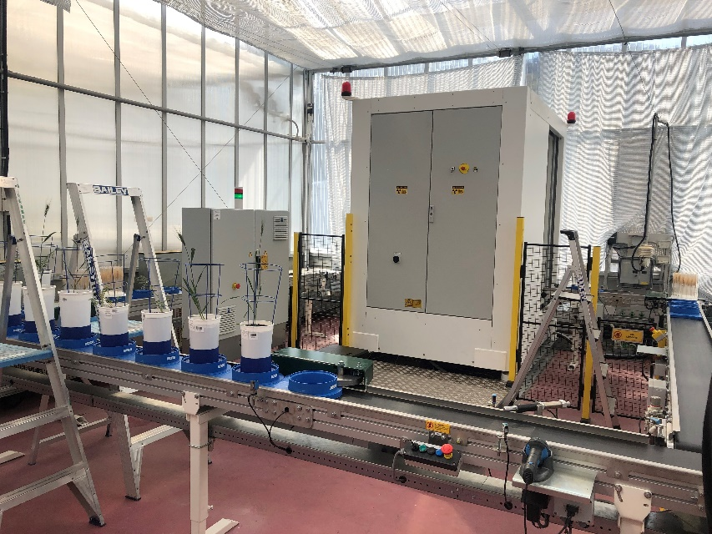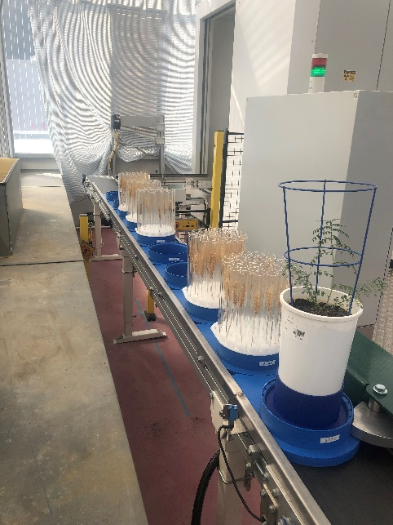
This capability will have major immediate applications in both cereal spike and root phenotyping. The system, built in collaboration with the Fraunhofer Institute in Erlangen-Fuerth (Germany), can be used to accurately and quickly phenotype large numbers of cereal spikes. Measurement of spike and grain traits is critical for plant scientists to understand the effect of abiotic stresses, such as frost, heat or drought on grain development. The high throughput enables the screening of large genetic mapping panels and for breeders to select superior crop varieties.
The X-ray CT system is situated adjacent to the Plant Accelerator automated high throughput imaging platforms. Shoots of plants are being phenotyped with high precision, and can be transferred to the X-ray CT system and then scanned non-destructively to produce a high resolution 3D model of their roots systems before being replaced on the shoot phenotyping platform. This enables understanding of root system architecture and response to treatments including fertiliser or abiotic and biotic stresses over time.

Pilot Project Examples
Opportunities to use the platform for pilot projects include:
- Undertaking pilot studies to support future grant applications.
- Undertaking new experiments or developing new protocols to add value to related research.
- Replicating previously completed experiments using the new platform to validate hypotheses.

Eligibility
Applications from all plant scientists in Australia will be considered. Priority will be given to projects relating to the grains industry.
EMCRs are strongly encouraged to apply.

Conditions of Funding
- Expressions of interest must be submitted by 17 December 2021 using the attached form.
- Pilot projects must be completed in 2022.
- Successful applicants must provide a short project report (using the template provided) within three months of project completion (i.e. from day of receipt of analysed X-ray CT data).
- Whilst the intellectual property will be owned by the client, the APPF will be entitled to release information about the pilot project output / data (e.g. the report provided by the applicant) on its website and/or other public domains.

Guidelines
- Assessment: Pilot project applications will be evaluated based on the scientific quality of the project and the degree to which the capabilities of the X-ray CT have been appropriated.
- Pricing: X-ray CT use for approved pilot projects is free.

Questions
For further questions please contact bettina.berger@adelaide.edu.au OR darren.plett@adelaide.edu.au

Applications / Expressions of Interest
Deadline: 17 December 2021
Expressions of interest must be submitted using the attached form by email to bettina.berger@adelaide.edu.au OR darren.plett@adelaide.edu.au

2021 APPF Pilot Project
X-ray CT Phenotyping Platform – The Plant Accelerator®
Expression of Interest
1. Applicant Details
Family Name: |  |  |  |  |  |  |  |  |  |  | Given Name:
Title: |  |  |  |  | Email address:
Phone: |  |  |  |  |  |  |  |  | Mobile or Home:
Organisation:
Department:
Postal Address:
PO Box or Street / Suburb / State / Post Code
2. Project Overview and hypothesis (100 words or less)
3. Please explain why this project is to be considered as a pilot project (100 words or less)
4. What additional data will be collected as part of the project?
e.g. manual grain measurements, root traits, etc

5. Other project information
Crop/developmental stage: |  |  |  |  |  |  |  |  |  |  |  |  | Target plant organ for imaging:
Total samples for imaging: |  |  |  |  |  |  |  |  |  |  |  |  |  |  | Number of imaging time points:
Anticipated start date: |  |  |  |  |  |  |  |  |  |  |  | Anticipated end date:
Origin of plants/samples: |  |  |  |  |  |  |  |  |  | TPA greenhouse/Other greenhouse/Field
Other environmental conditions / requirements / additional information:

Please return this form by 17 December 2021 by email to bettina.berger@adelaide.edu.au OR darren.plett@adelaide.edu.au

Pilot Project Report – X-ray CT Phenotyping Platform
Project Title:
Scientist:
Organisation:
Collaborators:
General information about the project design

Aims of the experiment

Key results and outputs

Statement on how data obtained from the X-ray CT provided new insights into your research

